# IR Receiver

An IR receiver is a sensor module that detects modulated infrared signals and converts them into electrical signals readable by microcontrollers.

**Working Principle:**It detects the 38kHz infrared signal sent by an IR remote. The photodiode inside receives the modulated light, which is decoded by an internal circuit and sent as a digital output.

**Types**:  
- TSOP1738 (common model)  
- Integrated with microcontrollers or as standalone modules

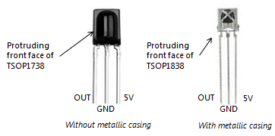**Applications**:  
- TV/AC/Set-top box receivers  
- Arduino IR control systems  
- Smart home appliances

**Advantages**:  
- Compact and reliable  
- Low power consumption  
- Easy to interface with Arduino

**Disadvantages**:  
- Requires line-of-sight  
- Limited range and angle Fig: IR Receiver Pin Layout